**Car Management Codes and Forms**

Login Form:

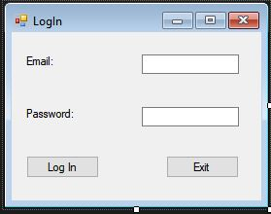

Login Codes:

using System;

using System.Data;

using System.Windows.Forms;

using System.Data.SqlClient;

namespace Car_Management

{

public partial class Form1 : Form

{

public Form1()

{

InitializeComponent();

}

private void btnLogIn_Click(object sender, EventArgs e)

{

try

{

string connected;

DatabaseConnection check = new DatabaseConnection();

connected = check.checkDatabase();

if (connected == "true")

{

using (SqlConnection conn = new SqlConnection(DatabaseConnection.connectionStr))

{

DataTable table = new DataTable();

SqlDataAdapter adapter = new SqlDataAdapter(@"select * from Contacts", conn);

adapter.Fill(table);

if (table.Rows.Count > 0)

{

Global.Client = new Cars

{

serialNumber = table.Rows[0]["SerialNumber"].ToString(),

Names = table.Rows[0]["Names"].ToString(),

plateNumber = table.Rows[0]["NumberPlates"].ToString(),

phoneNumber = table.Rows[0]["PhoneNumber"].ToString(),

address = table.Rows[0]["Address"].ToString(),

clientID = table.Rows[0]["ID"].ToString(),

clientAccount = table.Rows[0]["Account"].ToString(),

Technician = table.Rows[0]["Technician"].ToString(),

};

}

DataTable table1 = new DataTable();

SqlDataAdapter adapter1 = new SqlDataAdapter(@"select * from Technicians where Email = '" + txtEmail.Text + "' and Password = '" + txtPassword.Text + "'", conn);

adapter1.Fill(table1);

if (table.Rows.Count > 0)

{

Global.Technician = new Technicians

{

ID = table1.Rows[0]["ID"].ToString(),

Email = table1.Rows[0]["Email"].ToString(),

Password = table1.Rows[0]["Password"].ToString(),

Role = table1.Rows[0]["Role"].ToString(),

Names = table1.Rows[0]["Name"].ToString(),

Surnames = table1.Rows[0]["Surname"].ToString(),

//Position = table.Rows[0]["Position"].ToString(),

};

if (Global.Technician.Role == "Admin")

{

//Cars_and_Clients frmCar = new Cars_and_Clients();

//frmCar.Show();

ListviewTest frmlst = new ListviewTest();

frmlst.Show();

this.Hide();

}

else

{

MessageBox.Show("Normal use connected!");

}

}

DataTable table2 = new DataTable();

SqlDataAdapter adapter2 = new SqlDataAdapter(@"select * from Users", conn);

adapter2.Fill(table2);

if (table2.Rows.Count > 0)

{

Global.User = new Users

{

Names = table2.Rows[0]["Name"].ToString(),

Surnames = table2.Rows[0]["Surname"].ToString(),

Email = table2.Rows[0]["Email"].ToString(),

ID = table2.Rows[0]["ID"].ToString(),

phoneNumber = table2.Rows[0]["PhoneNumber"].ToString(),

Technician = table.Rows[0]["Technician"].ToString(),

};

}

}

}

else

{

MessageBox.Show("Connection to the database was not established.", "Error", MessageBoxButtons.OK, MessageBoxIcon.Error);

}

}

catch (Exception ex)

{

MessageBox.Show("No user exist with those credentials.Please try again!" + ex.Message, "Error", MessageBoxButtons.OK, MessageBoxIcon.Error);

}

}

private void btnExit_Click(object sender, EventArgs e)

{

Application.Exit();

}

private void Form1_Load(object sender, EventArgs e)

{

try

{

string connected;

DatabaseConnection check = new DatabaseConnection();

connected = check.checkDatabase();

if (connected == "true")

{

using (SqlConnection conn = new SqlConnection(DatabaseConnection.connectionStr))

{

SqlCommand cmd = new SqlCommand("Select Email FROM Technicians", conn);

conn.Open();

SqlDataReader reader = cmd.ExecuteReader();

AutoCompleteStringCollection MyCollection = new AutoCompleteStringCollection();

while (reader.Read())

{

MyCollection.Add(reader.GetString(0));

}

txtEmail.AutoCompleteCustomSource = MyCollection;

conn.Close();

}

}

else

{

MessageBox.Show("Connection to the database was not established.", "Error", MessageBoxButtons.OK, MessageBoxIcon.Error);

}

}

catch (Exception ex)

{

MessageBox.Show(ex.Message, "Error", MessageBoxButtons.OK, MessageBoxIcon.Error);

}

}

}

}

Existing client's car Form:

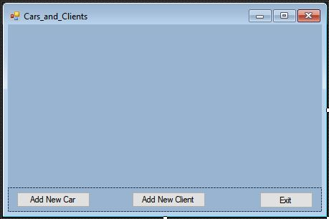

Codes:

using System;

using System.Data;

using System.Windows.Forms;

using System.Data.SqlClient;

namespace Car_Management

{

public partial class Cars_and_Clients : Form

{

public Cars_and_Clients()

{

InitializeComponent();

}

private void Cars_and_Clients_Load(object sender, EventArgs e)

{

string connected;

DatabaseConnection check = new DatabaseConnection();

connected = check.checkDatabase();

try

{

if (connected == "true")

{

using (SqlConnection conn = new SqlConnection(DatabaseConnection.connectionStr))

{

var select = "SELECT * FROM Contacts ";

var dataAdapter = new SqlDataAdapter(select, conn);

var commandBuilder = new SqlCommandBuilder(dataAdapter);

var ds = new DataSet();

dataAdapter.Fill(ds);

dataGridView1.ReadOnly = true;

dataGridView1.DataSource = ds.Tables[0];

dataGridView1.DefaultCellStyle.WrapMode = DataGridViewTriState.True;

}

}

else

{

MessageBox.Show("Connection to the database was not established.", "Error", MessageBoxButtons.OK, MessageBoxIcon.Error);

}

}

catch (Exception ex)

{

MessageBox.Show(ex.Message, "Error", MessageBoxButtons.OK, MessageBoxIcon.Error);

}

}

private void button1_Click(object sender, EventArgs e)

{

MessageBox.Show(Global.Technician.Names + " " + Global.Technician.Surnames);

New_Car frmNewCar = new New_Car();

frmNewCar.Show();

this.Hide();

}

private void btnExit_Click(object sender, EventArgs e)

{

this.Close();

Form1 frm1 = new Form1();

frm1.Show();

}

private void bntNewClient_Click(object sender, EventArgs e)

{

New_Client frmNewClient = new New_Client();

frmNewClient.Show();

this.Hide();

}

}

}

Registering New Car Form:

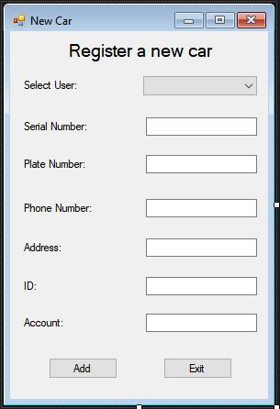

Codes:

using System;

using System.Windows.Forms;

using System.Data.SqlClient;

namespace Car_Management

{

public partial class New_Car : Form

{

public New_Car()

{

InitializeComponent();

}

private void button1_Click(object sender, EventArgs e)

{

try

{

string connected;

DatabaseConnection check = new DatabaseConnection();

connected = check.checkDatabase();

long i;

if (connected == "true")

{

if (txtSrlNum.Text != "" & txtPltNum.Text != "")

{

MessageBox.Show((long.TryParse(txtPltNum.Text, out i)).ToString());

string names = comboUsers.Text;

long PhoneNum = Convert.ToInt64(txtPhnNum.Text);

long srlNum = Convert.ToInt64(txtSrlNum.Text);

string plateNum = txtPltNum.Text;

string address = txtAddress.Text;

long IDnum = Convert.ToInt64(txtID.Text);

long account = Convert.ToInt64(txtAcc.Text);

string tech = Global.Technician.Names + " " + Global.Technician.Surnames;

using (SqlConnection conn = new SqlConnection(DatabaseConnection.connectionStr))

{

conn.Open();

string querry = "INSERT INTO Contacts(Names,PhoneNumber,SerialNumber,NumberPlates,Address,ID,Account,Technician) "

+ "Values('" + names + "','" + PhoneNum + "','" + srlNum + "','" + plateNum + "','" + address + "','" + IDnum + "','" + account + "','"+ tech+"')";

using (SqlCommand cmd = new SqlCommand(querry, conn))

{

cmd.ExecuteNonQuery();

MessageBox.Show("New Car added!");

txtSrlNum.Clear();

txtPltNum.Clear();

}

conn.Close();

}

}

else

{

MessageBox.Show("Please make sure you have entered all the required information", "Error", MessageBoxButtons.OK, MessageBoxIcon.Error);

}

}

else

{

MessageBox.Show("Not Connected");

}

}

catch (Exception ex)

{

MessageBox.Show(ex.Message);

}

}

private void button2_Click(object sender, EventArgs e)

{

this.Close();

Cars_and_Clients frmCars = new Cars_and_Clients();

frmCars.Show();

}

private void New_Car_Load(object sender, EventArgs e)

{

try

{

string connected;

DatabaseConnection check = new DatabaseConnection();

connected = check.checkDatabase();

if (connected == "true")

{

using (SqlConnection conn = new SqlConnection(DatabaseConnection.connectionStr))

{

SqlCommand cmd = new SqlCommand("Select Name,Surname FROM Users", conn);

conn.Open();

SqlDataReader reader = cmd.ExecuteReader();

AutoCompleteStringCollection MyCollection = new AutoCompleteStringCollection();

while (reader.Read())

{

MyCollection.Add(reader.GetString(0) +" " + reader.GetString(1));

}

comboUsers.DataSource = MyCollection;

conn.Close();

}

}

else

{

MessageBox.Show("Connection to the database was not established.", "Error", MessageBoxButtons.OK, MessageBoxIcon.Error);

}

}

catch (Exception ex)

{

MessageBox.Show(ex.Message, "Error", MessageBoxButtons.OK, MessageBoxIcon.Error);

}

}

}

}

Registering New Client Form:

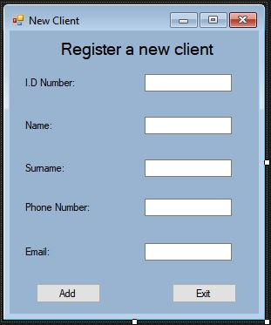

Codes:

using System;

using System.Windows.Forms;

using System.Data.SqlClient;

namespace Car_Management

{

public partial class New_Client : Form

{

public New_Client()

{

InitializeComponent();

}

private void btnExit_Click(object sender, EventArgs e)

{

this.Close();

Cars_and_Clients frmCars = new Cars_and_Clients();

frmCars.Show();

}

private void btnAddClient_Click(object sender, EventArgs e)

{

try

{

string connected;

DatabaseConnection check = new DatabaseConnection();

connected = check.checkDatabase();

if (connected == "true")

{

if (txtIDNum.Text != "" & txtName.Text != "")

{

string name = txtName.Text;

string surname = txtSurname.Text;

long PhoneNum = Convert.ToInt64(txtPhnNum.Text);

long IDNum = Convert.ToInt64(txtIDNum.Text);

string email = txtEmail.Text;

string tech = Global.Technician.Names + " " + Global.Technician.Surnames;

using (SqlConnection conn = new SqlConnection(DatabaseConnection.connectionStr))

{

conn.Open();

string querry = "INSERT INTO Users(ID,Name,Surname,Email,PhoneNumber,Technician) "

+ "Values('" + IDNum + "','" + name + "','" + surname + "','" + email + "','" + PhoneNum + "','" + tech + "')";

using (SqlCommand cmd = new SqlCommand(querry, conn))

{

cmd.ExecuteNonQuery();

MessageBox.Show("New Client added!");

}

conn.Close();

}

}

else

{

MessageBox.Show("Please make sure you have entered all the required information", "Error", MessageBoxButtons.OK, MessageBoxIcon.Error);

}

}

else

{

MessageBox.Show("Not Connected");

}

}

catch (Exception ex)

{

MessageBox.Show(ex.Message);

}

}

private void New_Client_Load(object sender, EventArgs e)

{

}

}

}

Display data from the device-Form:

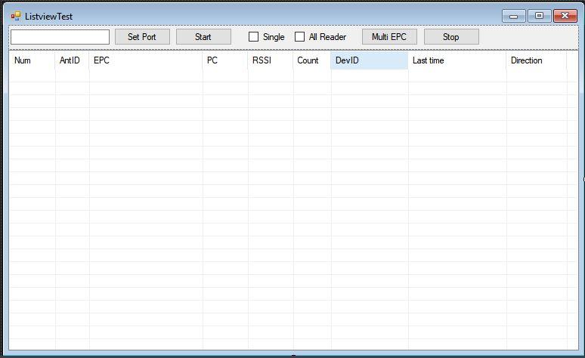

Codes:

using System;

using System.Collections.Generic;

using System.ComponentModel;

using System.Data;

using System.Drawing;

using System.Linq;

using System.Text;

using System.Threading.Tasks;

using System.Windows.Forms;

using System.Runtime.InteropServices;

using System.Threading; //thread

using System.IO.Ports; //SerialPort

using System.Text.RegularExpressions;

using System.Net;

using System.Data.SqlClient;

using System.Net.Sockets;

using NetFrame.Net.TCP.Sock.Asynchronous;

using System.Reflection;

using System.Resources;

using System.Globalization;

//using SQL;

namespace Car_Management

{

public partial class ListviewTest : Form

{

public ListviewTest()

{

InitializeComponent();

}

private long totalnum1 = 0x00;

private long totalnum2 = 0x00;

private long totaltime = 0x00;

private const int listView_md_epc_Num = 0;

private const int listView_md_epc_AntID = 1;

private const int listView_md_epc_EPC = 2;

private const int listView_md_epc_PC = 3;

private const int listView_md_epc_Rssi = 4;

private const int listView_md_epc_Count = 5;

private const int listView_md_epc_IP = 6;

private const int listView_md_epc_Last_Time = 7;

private const int listView_md_epc_Direction = 8;

private volatile List<_epc_t> epcs_list = new List<_epc_t>(1000);

private string portname = "";

private int baudRate = 230400;

private int dataBits = 8;

private Parity parity = Parity.None;

private StopBits stopbits = StopBits.One;

private void btnSet_Click(object sender, EventArgs e)

{

PortConfig SerialPortForm = new PortConfig();

SerialPortForm.ShowDialog();

if (SerialPortForm.result == true)

{

textBox1.Text = SerialPortForm.PortName;

portname = textBox1.Text;

baudRate = SerialPortForm.BuadRate;

dataBits = SerialPortForm.dataBits;

parity = SerialPortForm.parity;

stopbits = SerialPortForm.stopbits;

}

}

bool serialisstart = false;

bool serverisstart = false;

private Reader ReaderControllor = new Reader();

private AsyncSocketState currentclient;

private void btnStartPort_Click(object sender, EventArgs e)

{

if (btnStartPort.Text == "Start")

{

portname = textBox1.Text;

try

{

ReaderControllor.ComStart(portname, baudRate, dataBits, parity, stopbits);

if (timer_md_query_Tick.Enabled == false)

{

timer_md_query_Tick.Enabled = true;

}

}

catch (Exception ex)

{

// UpdateLog("Error:" + ex.ToString());

}

serialisstart = true;

btnStartPort.Text = "Stop";

//UpdateLog(openserial + success);

}

else

{

serialisstart = false;

ReaderControllor.SerialPortClose();

if (serverisstart == false && serialisstart == false && timer_md_query_Tick.Enabled == true)

{

timer_md_query_Tick.Enabled = false;

}

btnStartPort.Text = "Start";

//UpdateLog(closeserial + success);

}

}

private void btnMultiEPC_Click(object sender, EventArgs e)

{

try

{

if (checkBoxMulti.Checked == true)

{

if (checkBoxSingle.Checked == true)

{

ReaderControllor.SingleEPC();

}

else

{

ReaderControllor.SatrtMultiEPC();

}

}

else

{

if (checkBoxSingle.Checked == true)

{

ReaderControllor.SingleEPC(currentclient);

}

else

{

ReaderControllor.SatrtMultiEPC(currentclient);

}

}

//UpdateLog(start + multiepc + success);

}

catch (Exception ex)

{

//UpdateLog(ex.ToString());

}

}

private void timer_md_query_Tick_Tick(object sender, EventArgs e)

{

totalnum1 = 0;

totaltime++;

//label10.Text = totaltime.ToString();

//epcs_list = ReaderControllor.GetMultiEPC();

//label26_total.Text = epcs_list.Count.ToString();

for (int index = 0; index < epcs_list.Count; index++)

{

string str_epc = epcs_list[index].epc;

string str_pc = epcs_list[index].PC.ToString("X2");

string str_read_cnt = epcs_list[index].count.ToString();

string str_ant_id = epcs_list[index].antID.ToString();

string str_dev = epcs_list[index].dev;

string str_ip = epcs_list[index].ClientIP;

string str_time = epcs_list[index].time;

string str_rssi = epcs_list[index].RSSI.ToString("f1");

string direction = epcs_list[index].direction.ToString();

totalnum1 += epcs_list[index].count;

bool Exist = false;

int item_index = 0;

foreach (ListViewItem viewitem in this.listView_md_epc.Items)

{

if ((viewitem.SubItems[listView_md_epc_EPC].Text == str_epc) && (viewitem.SubItems[listView_md_epc_IP].Text == str_dev))

{

viewitem.SubItems[listView_md_epc_AntID].Text = str_ant_id;

viewitem.SubItems[listView_md_epc_Count].Text = str_read_cnt;

viewitem.SubItems[listView_md_epc_Last_Time].Text = str_time;

viewitem.SubItems[listView_md_epc_PC].Text = str_pc;

viewitem.SubItems[listView_md_epc_Rssi].Text = str_rssi;

viewitem.SubItems[listView_md_epc_Direction].Text = direction;

Exist = true;

break;

}

item_index++;

}

if (!Exist)

{

ListViewItem item = new ListViewItem((this.listView_md_epc.Items.Count + 1).ToString());

item.SubItems.Add(str_ant_id);

item.SubItems.Add(str_epc);

item.SubItems.Add(str_pc);

item.SubItems.Add(str_rssi);

item.SubItems.Add(str_read_cnt);

item.SubItems.Add(str_dev);

item.SubItems.Add(str_time);

item.SubItems.Add(direction);

this.listView_md_epc.Items.Add(item);

this.listView_md_epc.Items[this.listView_md_epc.Items.Count - 1].EnsureVisible();

this.listView_md_epc.Items[this.listView_md_epc.Items.Count - 1].Selected = true;

// this.listView_md_epc.Items[this.listView_md_epc.Items.Count - 1].BackColor = System.Drawing.Color.FromArgb(red, green, blue);

}

}

//label8.Text = (totalnum1 - totalnum2).ToString();

totalnum2 = totalnum1;

}

private void ListviewTest_Load(object sender, EventArgs e)

{

}

private void btnStop_Click(object sender, EventArgs e)

{

try

{

if (checkBoxMulti.Checked == true)

{

if (checkBoxSingle.Checked == true)

{

;

}

else

{

ReaderControllor.StopMultiEPC();

//UpdateLog(stop + multiepc + success);

}

}

else

{

if (checkBoxSingle.Checked == true)

{

;

}

else

{

ReaderControllor.StopMultiEPC(currentclient);

//UpdateLog(stop + multiepc + success);

}

}

}

catch (Exception ex)

{

//UpdateLog(ex.ToString());

}

}

}

}

Port configuration Form:

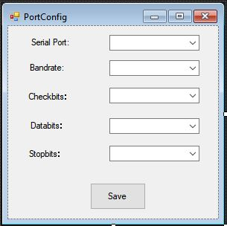

Codes:

using System;

using System.Windows.Forms;

using System.IO.Ports;

namespace Car_Management

{

public partial class PortConfig: Form

{

public string PortName = "";

public int BuadRate = 0;

public int dataBits = 0;

public Parity parity = 0;

public StopBits stopbits = 0;

public bool result = false;

public PortConfig()

{

InitializeComponent();

string[] names = SerialPort.GetPortNames();

foreach (string name in names)

{

comboBox1.Items.Add(name);

}

comboBox1.SelectedIndex = 0;

comboBox2.SelectedIndex = 7;

comboBox3.SelectedIndex = 0;

comboBox4.SelectedIndex = 3;

comboBox5.SelectedIndex = 1;

}

private void button1_Click(object sender, EventArgs e)

{

PortName = comboBox1.Text;

BuadRate = int.Parse(comboBox2.Text);

dataBits = int.Parse(comboBox4.Text);

parity = (Parity)comboBox3.SelectedIndex;

stopbits = (StopBits)comboBox5.SelectedIndex;

result = true;

this.Close();

}

}

}